Written Assignment Unit 1

Godfrey Ouma
University of the People
MATH 1211: Calculus
Rakesh Das
November 22, 2023

Written Assignment Unit 1
- What linear function, $y=f(x)$ has $f\left(0\right)=8$ and $f\left(7\right)=14$?
For $f\left(0\right)=8$ and $f\left(7\right)=8$, it implies that the linear function is passing through the points (0,8) and (7,14) respectively. The slope of the linear function can be determined as follows: $m=\frac{y_{2}-y_{1}}{x_{2}-x_{1}}=\frac{14-8}{7-0}=\frac{6}{7}$.
Using the point-slope form, $y-y_{1}=m(x-x_{1})$.
$$y-14=\frac{6}{7}\left(x-7\right)$$
Therefore, the linear function becomes $y=\frac{6}{7}x+8$.
- If $f\left(t\right)={2t-t}^{2}+3$, what is $\frac{f\left(t+h\right)-f(t)}{h}$?
$$\frac{f\left(t+h\right)-f(t)}{h}=\frac{2\left(t+h\right)-({t+h)}^{2}+3-({2t-t}^{2}+3)}{h}$$
$$=\frac{{(-t}^{2}+2t-2th-h^{2}+2h+3)-({2t-t}^{2}+3)}{h}$$
$$=\frac{-2th-h^{2}+2h}{h}$$
$$=\frac{h(-2t-h+2)}{h}$$
$$=-2t-h+2$$
- Find all solutions to the equation $-4cosx=-\sin^{2}x+1$. Write your answer in radians in terms of $π$.
$-4cosx=-\sin^{2}x+1$
$\sin^{2}x=1-\cos^{2}x$
$-4cosx=-1+\cos^{2}x+1$
$0=\cos^{2}x+4cosx$
$0=cosx(cosx+4)$
$cosx=0$ or $cosx+4=0$
For $cosx=0$, $the solutions are$ $x=\frac{π}{2}+nπ$ and $x=\frac{3π}{2}+nπ$, where n is an integer.
For $cosx+4=0$, solving for $cosx$ gives $cosx=-4$, which has no real solutions because the cosine function has a range of (1,1).
- Sketch the graph of $y=3^{x+2}+5$. Find the domain, range, and horizontal asymptote. Include the horizontal asymptote in your graph.
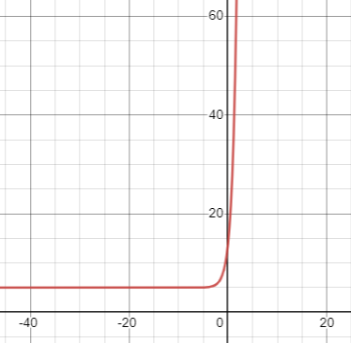
Domain: $(-∞<x<∞)$.
Range: $(5,∞)$.
Horizontal asymptote: $y=5$.
- Sketch $\log_{3}\left(x+2\right)+5$. Find the domain, range, and vertical asymptote. Include the vertical asymptote in your graph.
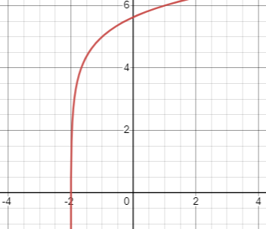
Vertical asymptote: $x=-2$
Domain: $(-2,∞)$
Range: $(-∞,∞)$
Vertical asymptote: $x=-2$
- Find the domain of the function $g\left(x\right)=\frac{2x}{x^{2}-81}$.
Solving the denominator: $x^{2}-81$, $x=±9$. This means that g(x) will become undefined at $x=9$ and $x=-9$. Therefore, domain becomes $\left(-∞,-9\right)U\left(-9,9\right)U(9,+∞)$.
- From the graph below, find what is $f(-15)$ and for what numbers $x$ is $f\left(x\right)=0$.
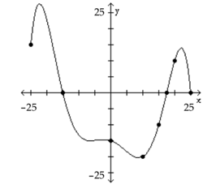
From the graph, $f(-15)=0$, and the values of x when $f(x)=0$ is -15 and 17.5.
- Determine whether the graph is that of a function. If it is, use the graph to find its domain, and range, the intercepts, if any, and any asymptote with respect to the x-axis, the y-axis, or the origin.
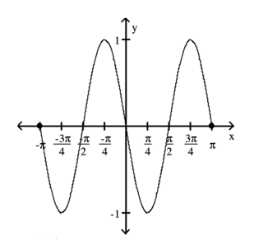
The graph is a function since the vertical line cuts it once.
Domain: $(-π,π)$
Range: $(1,-1)$
Horizontal asymptote: $y=1$ and $y=-1$
- Determine whether the function is even, odd, or neither.
- $f\left(x\right)=4x^{3}$
This is an odd function
- $f\left(x\right)=\frac{-x^{3}}{4x^{2}+3}$
This is an even function
- $f\left(x\right)=3x^{3}-5$
This is neither an even function nor an odd function.
- A cellular phone plan had the following schedule of charges: Basic service, including 100 minutes of calls is $20.00/per month; 2nd 100 minutes of calls is $0.075/minute; additional minutes of calls is $0.10/minute.
- What is the charge for 200 minutes of calls in one month?
100 minutes are covered by the basic service ($20.00).
The next 100 minutes are charged at $0.075 per minute.
Total charge for 200 minutes: $20.00+(0.075*100)=\$27.50$
- What is the charge for 250 minutes of calls in one month?
100 minutes are covered by the basic service ($20.00).
The next 100 minutes are charged at $0.075 per minute.
The remaining 50 minutes are charged at $0.10 per minute.
Total charge for 250 minutes: $20.00+(0.075*100)+(0.10*50)=\$32.50$
- Construct a function that relates the monthly charge C for x minutes of calls?
For $x≤100$ minutes: $C=20.00$
For $100<x≤200$ minutes: $C=\left(20.00+0,075\right)*\left(x-100\right)$
For $x>200$ minutes: $C=20.00+(0.075*100)+0.10(x-200)$

